Fire Marshal Division
August 7, 2023

Smith Woodworks Inc.
PO Box 365
Coats, NC 27521

RE: Coats Methodist Church
288 E South St.
Coats, NC 27521

Application – BCOM2308-0005

To Whom It May Concern,

Thank you for submitting the plans for the building renovation. The plans have been carefully reviewed by a qualified code enforcement official to examine for full compliance with the North Carolina Fire Prevention Code and all other fire protection regulatory documents. There are some items that were found during the plan review process that need to be addressed before a final inspection of the new facility can be given. These items are outlined and described below.

- Fire Extinguishers
  - Fire extinguishers shall be placed in approved locations.
  - The fire extinguishers provided shall have a minimum rating of 2A 10B: C and shall not be installed higher than 5 feet above the finished floor.

- Emergency Lighting
  - All emergency lighting shall be in proper operating condition at time of final inspection.
  - Any changes made in illumination requirements, due to equipment placement or storage arrangements shall be addressed before final inspection.

Thank you again for submitting the plans for the building renovation. Please review the plans and adhere to any notes and alterations that were made in addition to the original drawings. These remarks are for the plans that were submitted and its original intent. These remarks do not apply if the original intent changes or what was submitted on the above date changes. If you have any questions, please do not hesitate to call this office

Again, thank you and we look forward to working with you during the construction period!

Contact our office for final inspection 910-893-0740

Sincerely,
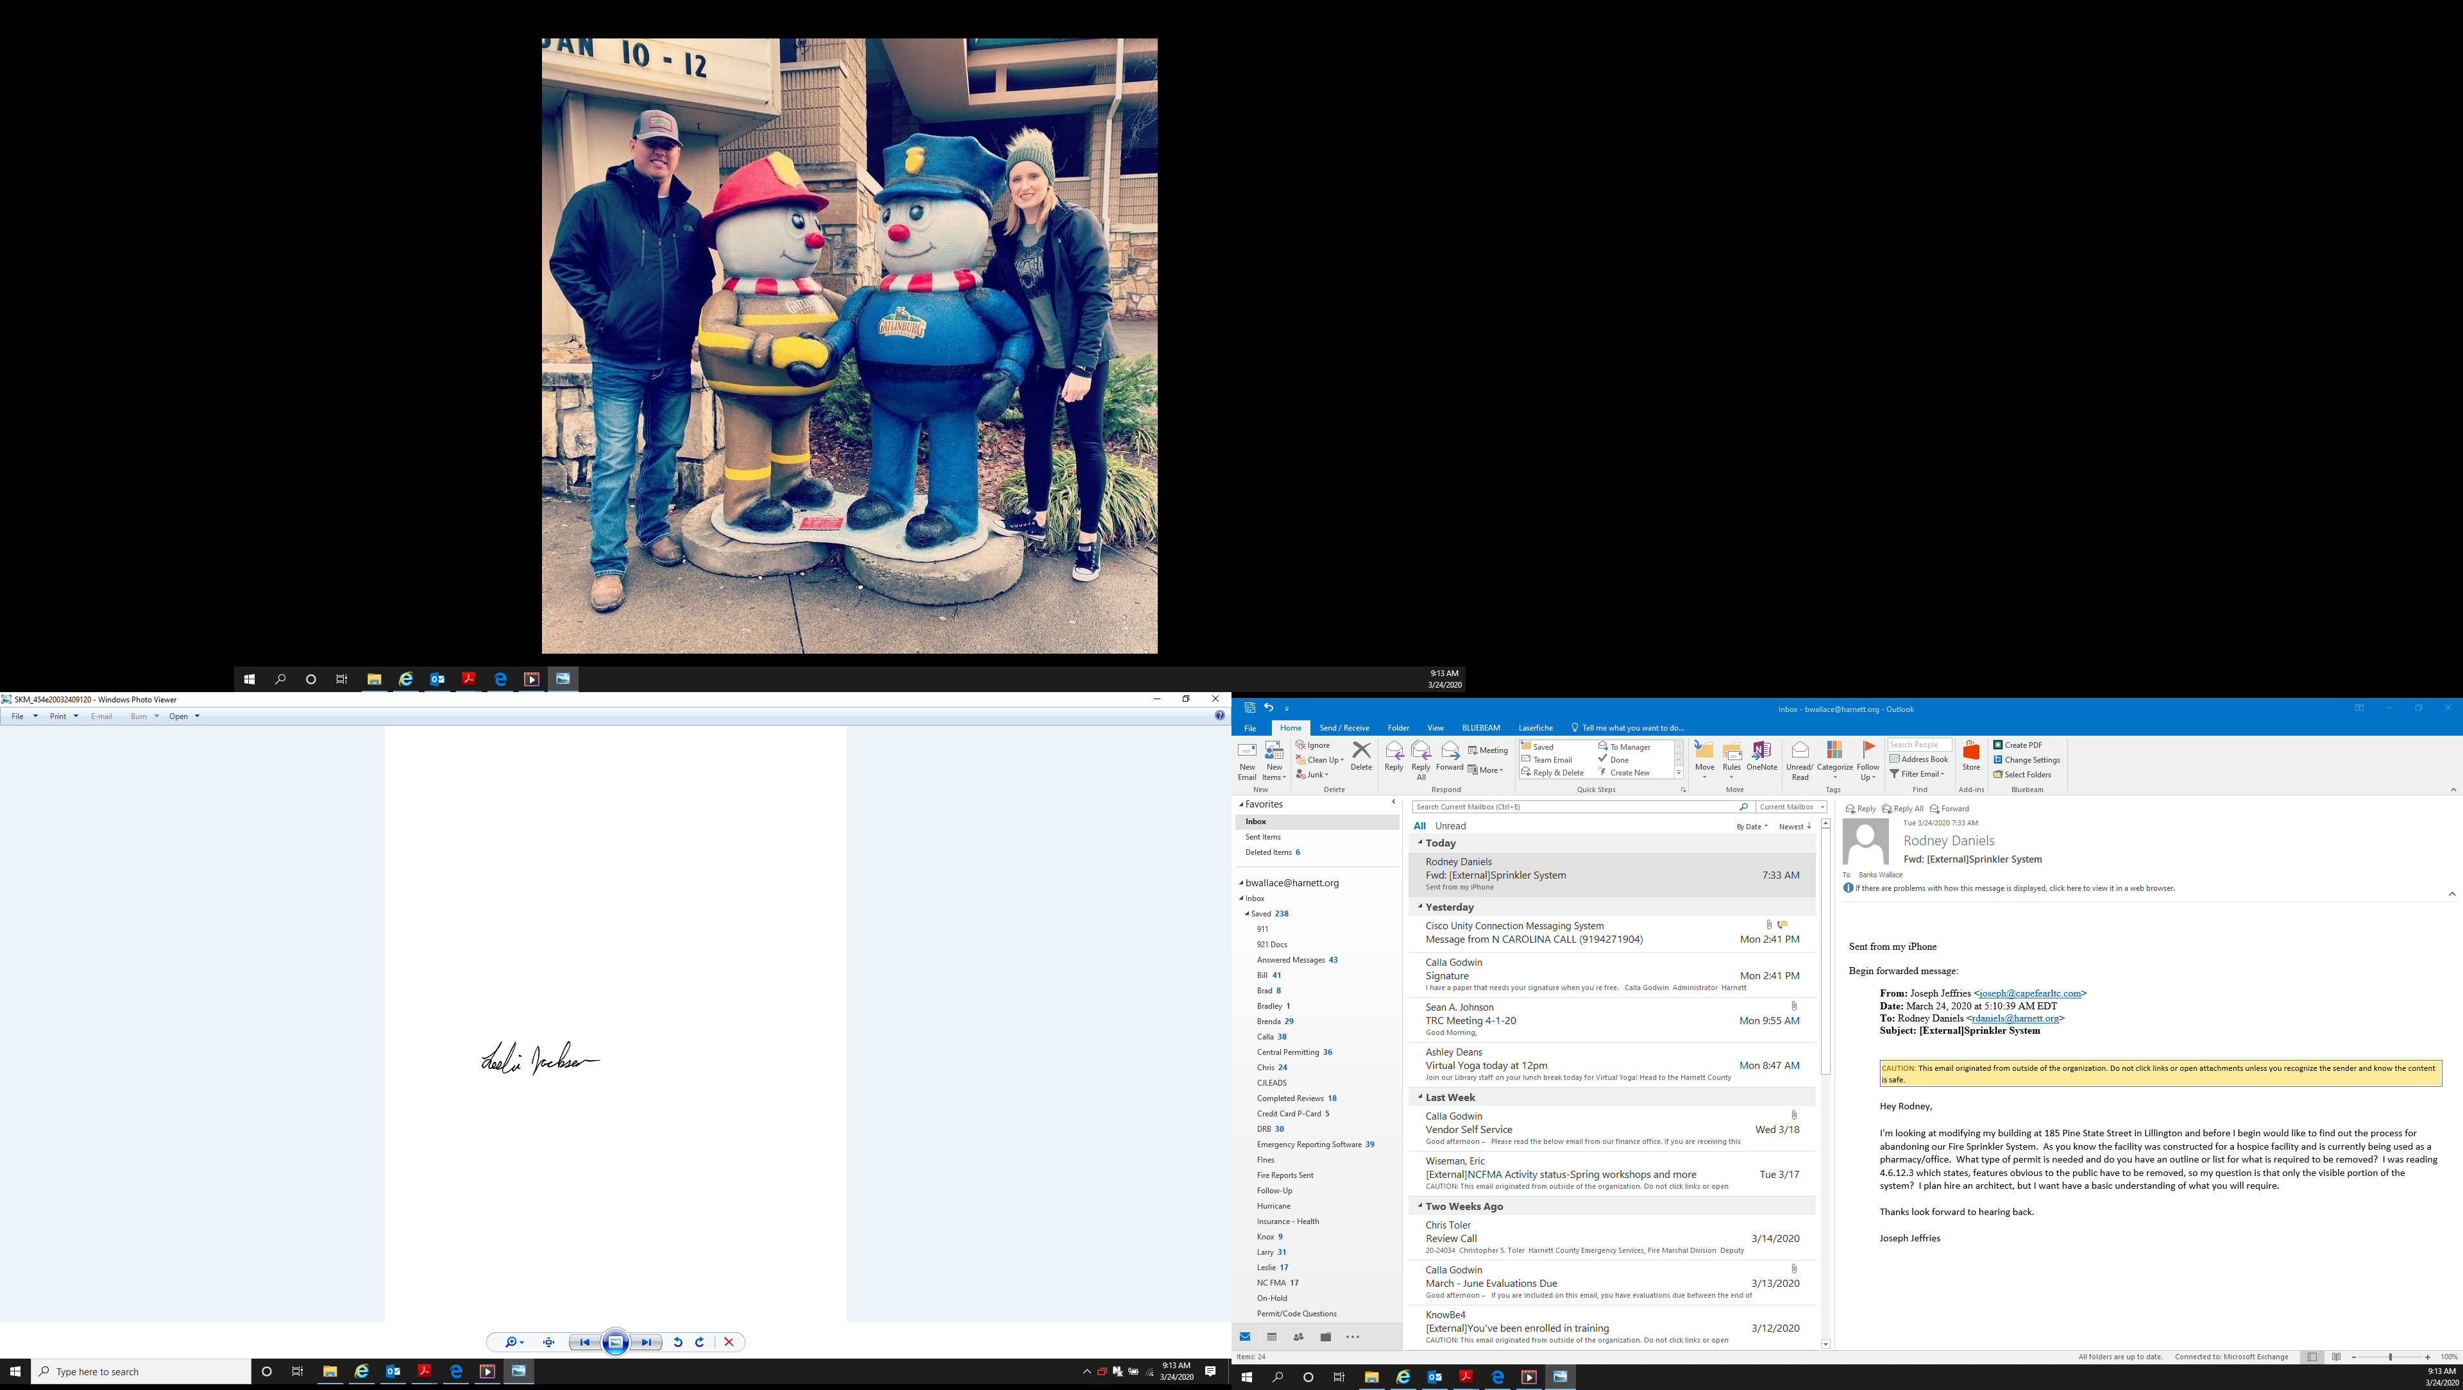

Leslie Jackson
Chief Deputy Fire Marshal
lrjackson@harnett.org

