Fire Marshal Division

August 8, 2023

Summit Fire Security
1731 Roundrock Dr.
Raleigh, NC 27615

Re: Fairway Point Bldg. 15
240 Fairway Dr.
Spring Lake, NC 28390

To Whom It May Concern,

Thank you for submitting the sprinkler system plans for Fairway Point Bldg. 15. The plans have been carefully reviewed by a qualified code enforcement official to examine for compliance with the North Carolina Fire Prevention Code and all other fire protection regulatory documents. There are some items that were found during the plan review process that need to be addressed before a final inspection of the new facility can be given. These items are outlined and described below.

- Notes
- Installation of the sprinkler system shall be per contract specifications

Installation acceptance testing.
  - All piping and attached appurtenances subjected to system working pressure shall be hydrostatically tested at 200 psi or 50 psi in excess of the system working pressure, whichever is greater, and shall maintain that pressure without loss for 2 hours. This test is required to be witnessed by a representative from the Harnett County Fire Marshal’s Office.
  - A contractor’s material and test certificate shall be furnished by the trained representative before final approval.
  - A piping and hanger inspection is required before closure of ceiling system(s).
  - A sprinkler final inspection is required at completion of project.
  - Schedule all inspections with the Fire Marshal’s Office. 910-893-0740

Thank you again for submitting the sprinkler plans. Please review the plans and adhere to any notes and alterations that were made in addition to the original drawings. These remarks are for the plans that were submitted and its original intent. These remarks do not apply if the original intent changes or what was submitted on the above date changes. If you have any questions, please do not hesitate to call this office.

Sincerely,
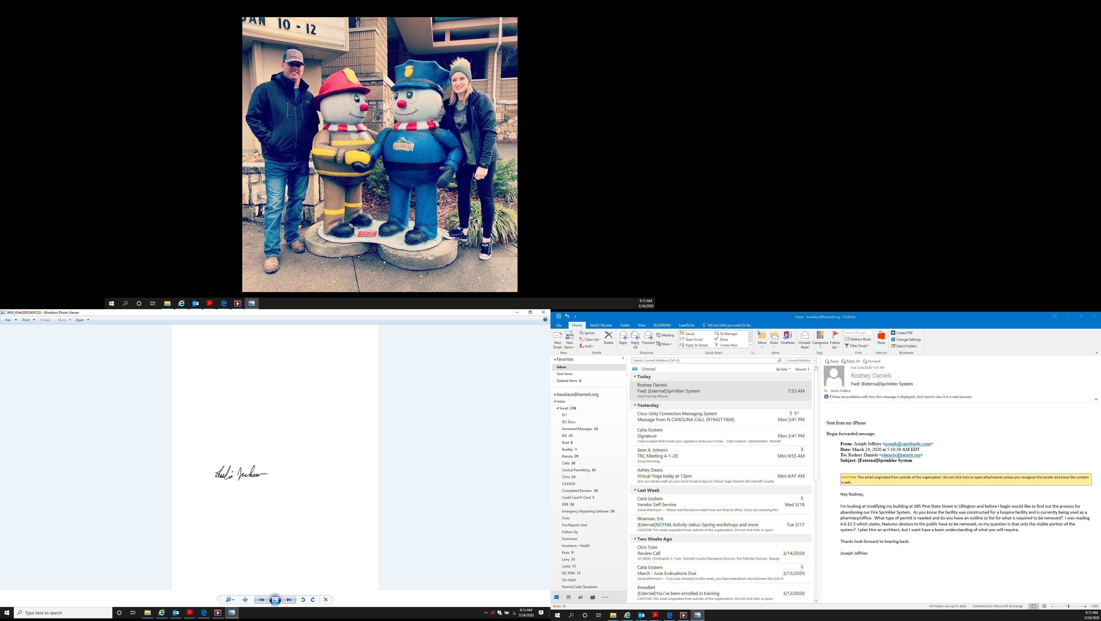

Leslie Jackson
Chief Deputy Fire Marshal
lrjackson@harnett.org

