Fire Marshal Division

June 7, 2023

Angel Myatt

Re: Boone Trail Elem. Pre K School
1425 Adcock Rd.
Lillington, NC 27546

Application Number – BCOM2306-0001

Mrs. Angel Myatt,

Thank you for submitting the plans for the Boone Trail Elem. Pre K School classroom 308. The plans have been carefully reviewed by a qualified code enforcement official to examine for full compliance with the North Carolina Fire Prevention Code and all other fire protection regulatory documents. There are some items that were found during the plan review process that need to be addressed before a final inspection of the new facility can be given. These items are outlined and described below.

1003.2.11 Means of egress illumination.
  - The means of egress, including the exit discharge, shall be illuminated at all times the building space served by the means of egress is occupied
  - The portion of the exterior exit discharge immediately adjacent to exit discharge doorways in buildings required to have two or more exits.
- 906.1 Fire Extinguishers
  - Fire extinguishers shall be located as not to exceed 75’ of travel distance to an extinguisher.
  - The fire extinguishers provided shall have a minimum rating of 2A10:BC and shall not be installed higher than 5 feet above the finished floor.

- 404.2 Fire Safety and Evacuation Plans
  - An approved fire safety and evacuation plan shall be prepared, posted and maintained for Group E occupancies.

- Notes
- Please schedule all fire inspections with the Fire Marshal’s Office.
- 910-893-0740

Thank you again for submitting the plans for the Boone Trail Elem. Pre K School classroom 308. Please review the plans and adhere to any notes and alterations that were made in addition to the original drawings. These remarks are for the plans that were submitted and its original intent. These remarks do not apply if the original intent changes or what was submitted on the above date changes. If you have any questions, please do not hesitate to call this office

Again, thank you and we look forward to working with you during the construction period!

Sincerely,
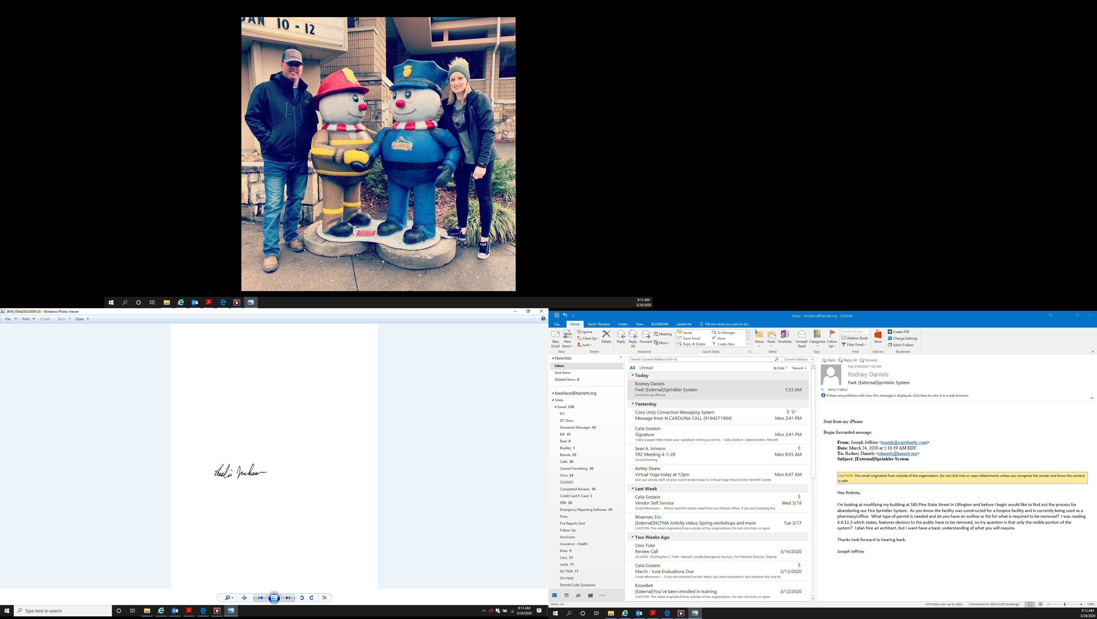

Leslie Jackson
Chief Deputy Fire Marshal
lrjackson@harnett.org

