Fire Marshal Division
January 23, 2023

RE: 302 E Stewart St.
Coats, NC 27521

Application – BCOM2301-0006

To Whom It May Concern,

Thank you for submitting the plans for the building upfit. The plans have been carefully reviewed by a qualified code enforcement official to examine for full compliance with the North Carolina Fire Prevention Code and all other fire protection regulatory documents. There are some items that were found during the plan review process that need to be addressed before a final inspection of the new facility can be given. These items are outlined and described below.

- Fire Extinguishers
  - Fire extinguishers shall be placed in approved locations.
  - The fire extinguishers provided shall have a minimum rating of 2A 10B: C and shall not be installed higher than 5 feet above the finished floor.

- Emergency Lighting
  - All emergency lighting shall be in proper operating condition at time of final inspection.
  - Any changes made in illumination requirements, due to equipment placement or storage arrangements shall be addressed before final inspection.

- Knox Box
- Keys for front entrance door shall be provided to be placed in the box installed on the premises.

- Physical Address ( ie: suite Number if Applicable )
- The physical address of the building shall be posted in a conspicuous place so that it can be seen on approach from the road, access road, and/or parking lot.

- The numbers used to make up the physical address shall be at least 6 inches in height.
- The physical address needs to be posted on the rear of the building also.

Thank you again for submitting the plans for the building upfit. Please review the plans and adhere to any notes and alterations that were made in addition to the original drawings. These remarks are for the plans that were submitted and its original intent. These remarks do not apply if the original intent changes or what was submitted on the above date changes. If you have any questions, please do not hesitate to call this office

Again, thank you and we look forward to working with you during the construction period!

Contact our office for final inspection 910-893-0740

Sincerely,
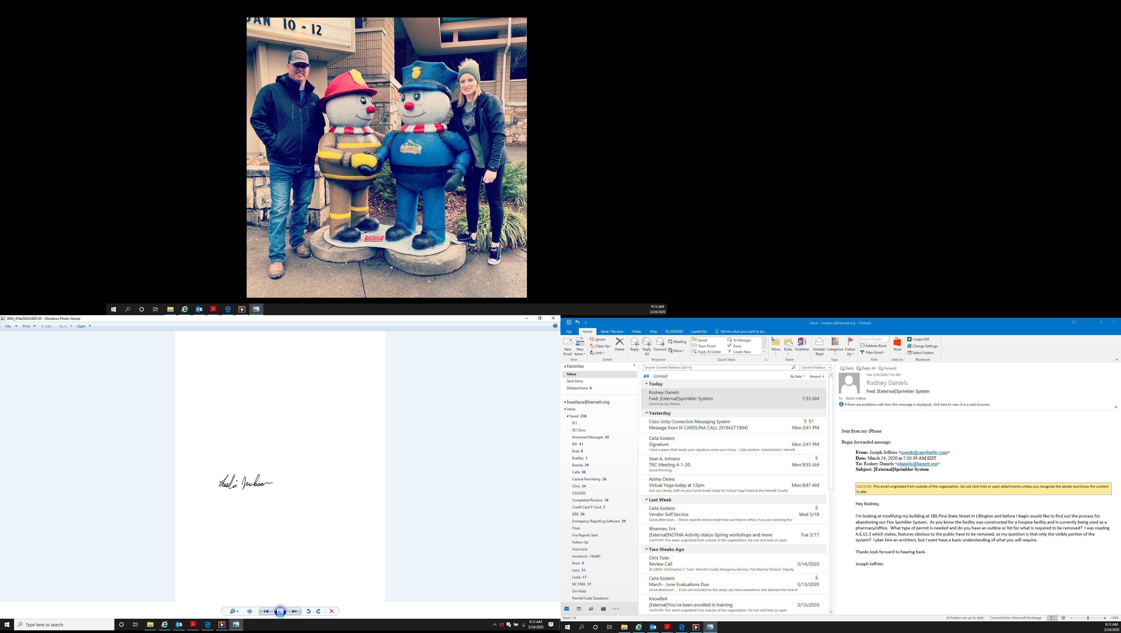

Leslie Jackson
Chief Deputy Fire Marshal
lrjackson@harnett.org

