Fire Marshal Division
October 26, 2022

O’Quinn Brooks
P.O. Box 618
Mamers, N.C. 27552

Re: O’Quinn Mini Storage
5630 Spring Hill Church Road
Lillington, NC 27546

Application Number BCOM2210-0005

To Whom It May Concern,

Thank you for submitting the plans for the storage building. The plans have been carefully reviewed by a qualified code enforcement official to examine for compliance with the North Carolina Fire Prevention Code and all other fire protection regulatory documents. There are some items that were found during the plan review process that need to be addressed before a final inspection of the new facility can be given. These items are outlined and described below.

Fire Extinguishers
  - Fire extinguishers shall be placed not to exceed 75’ travel distance.
  - The fire extinguishers provided shall have a minimum rating of 2A 10B: C and shall not be installed higher than 5 feet above the finished grade.

Fire Department Access
  - The fire department access shall extend to within 150 feet of all portions of the facility (current driveway and parking lot may suffice).
  - The fire department access road shall be of an unobstructed width of not less than 20 feet and shall have an unobstructed vertical clearance of not less the 13 feet 6 inches.
Knox Box
- The main entry gate must have a knox entry key system installed for fire department access, contact our office for further details if needed.

- Notes
- Please schedule fire final inspection through the Fire marshal’s office.
- 910-893-0740

Thank you again for submitting the plans for the storage building. Please review the plans and adhere to any notes and alterations that were made in addition to the original drawings. These remarks are for the plans that were submitted and its original intent. These remarks do not apply if the original intent changes or what was submitted on the above date changes. If you have any questions, please do not hesitate to call this office

Again, thank you and we look forward to working with you during the construction period!

Sincerely,
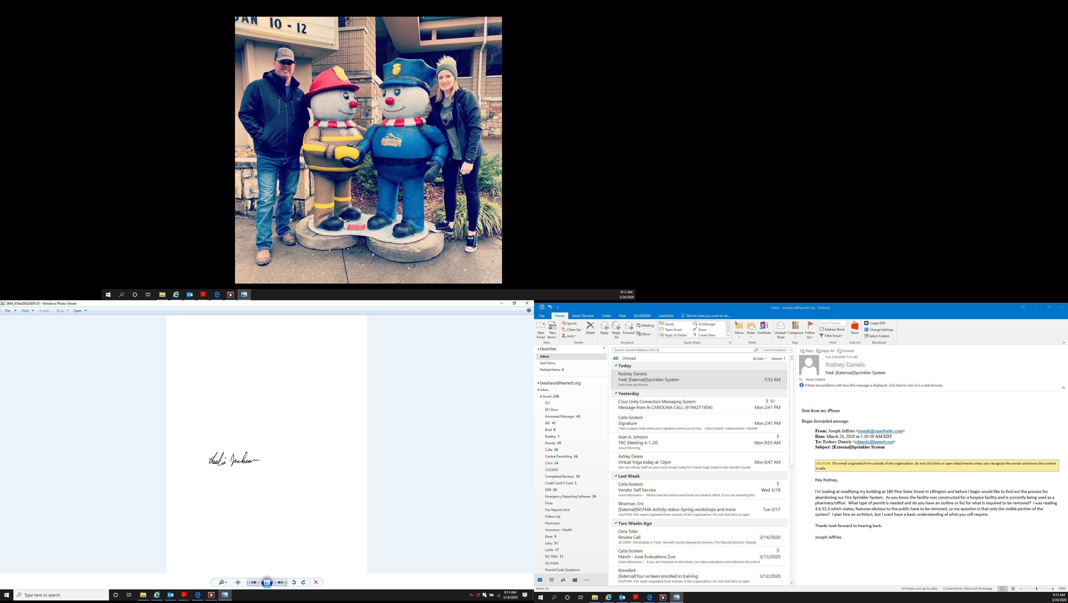

Leslie Jackson
Chief Deputy Fire Marshal
lrjackson@harnett.org

