Fire Marshal Division

October 4, 2022

Jenkins All American Alarms
1606 McArthur Rd.
Fayetteville, NC 28311

Re: Potters Vessel Church Day Care
215 Coats Rd.
Linden, NC 28356

Application Number BCOM-0007

To Whom It May Concern,

Thank you for submitting the plans for the fire alarm system. The plans have been carefully reviewed by a qualified code enforcement official to examine for compliance with the North Carolina Fire Prevention Code and all other fire protection regulatory documents. There are some items that were found during the plan review process that need to be addressed before a final inspection of the facility can be given. These items are outlined and described below.
- Fire Alarm System Notes

All items in notes are to be completed at the time of final.
- Provide a record of completion.
- The Fire marshal’s office will complete an acceptance test at completion of project.
- Provide a copy of account history after the acceptance test is completed and approve.
- Provide an accurate zone map at the FACP and remote annunciator panel.
- All work/installation shall be compliant with the NCSFC and NFPA 72.
- Call Fire Marshal’s office to schedule the fire alarm acceptance test. (910-893-0740)

- Notes

- A fire alarm construction permit is required.
- Please schedule all inspections through the Fire Marshal’s Office.
910-893-0740.

Thank you again for submitting the plans for the fire alarm system. Please review the plans and adhere to any notes and alterations that were made in addition to the original drawings. If you have any questions, please do not hesitate to call this office.

Again, thank you and we look forward to working with you during the construction period!

Sincerely,
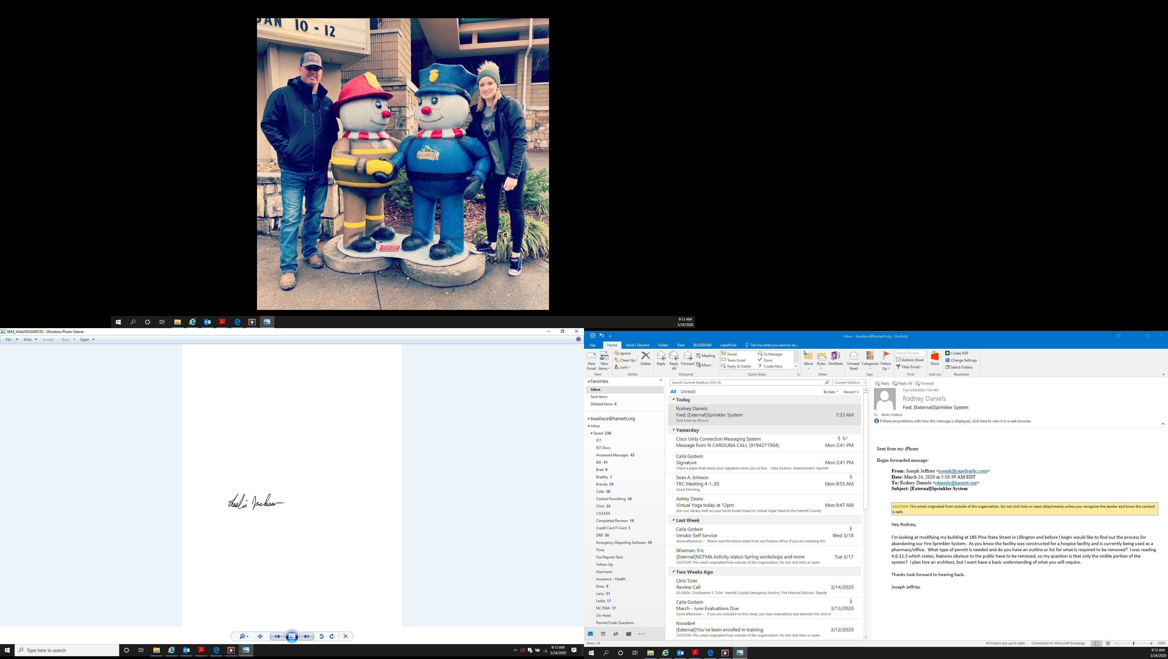

Leslie Jackson
Chief Deputy Fire Marshal
lrjackson@harnett.org

