June 21, 2022

G L Strickland Construction LLC
1409 Clinton Rd.
Fayetteville, NC 28312

Lexington Plantation Pool House
400 Centennial Parkway
Cameron, NC 28326

Application Number BCOM2206-0003

Thank you for submitting the plans for the pool house. The plans have been carefully reviewed by a qualified code enforcement official to examine for full compliance with the North Carolina Fire Prevention Code and all other fire protection regulatory documents. There are some items that were found during the plan review process that need to be addressed before a final inspection of the new facility can be given. These items are outlined and described below.

- 906.1 Fire Extinguishers
  - Fire extinguishers shall be placed in approved locations as drawn by the code enforcement official on the approved plans.
  - The fire extinguishers provided shall have a minimum rating of 2A 10B:C and shall not be installed higher than 5 feet above the finished floor
  - As noted on plans

- 506.1 Knox Box
  - A secure key box shall be installed on the new building that houses all keys to all the doors within the building in which the fire department would need access to in the event of an emergency.
    - Knox Box ID stickers shall be placed on all exterior doors in which entry to the building may be gained. Stickers are to be ordered through the order form.
  - The box shall be mounted not to exceed 48 – 60 inches in height.
  - An authorized order form is included with this letter.

- 505.1 Physical Address
- The physical address of the building shall be posted in a conspicuous place so that it can be seen on approach from the road, access road, and/or parking lot.
- The numbers used to make up the physical address shall be at least 5 inches in height.
- The address shall be posted on the interior of the building indicating the suite location in a conspicuous manner.

- NFPA 704 Placard
  - A NFPA 704 Placard shall be placed on the building. The ratings listed on the NFPA 704 placard shall be in accordance with the chemicals stored in the storage area.

Thank you again for submitting the plans for the clubhouse. Please review the plans and adhere to any notes and alterations that were made in addition to the original drawings. These remarks are for the plans that were submitted and its original intent. These remarks do not apply if the original intent changes or what was submitted on the above date changes. If you have any questions, please do not hesitate to call this office.

Again, thank you and we look forward to working with you during the construction period!

Sincerely,
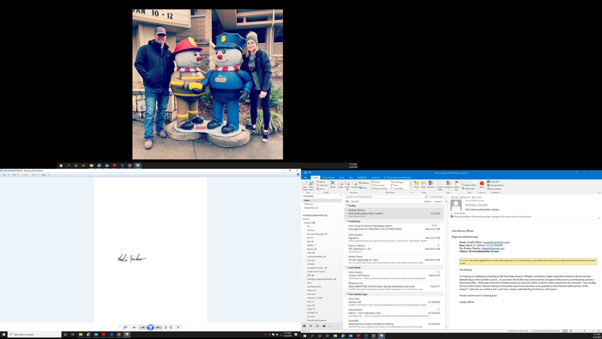

Leslie Jackson
Chief Deputy Fire Marshal
lrjackson@harnett.org

