Fire Marshal Division
April 29, 2022

Wilson Office
213 E. Nash St.
Wilson, NC 27893

Re: Dollar General (Mamers)
US 421 North
Lillington, NC 27546

Application Number BCOM2204-0005

To Whom It May Concern,

Thank you for submitting the plans for the new Dollar General. The plans have been carefully reviewed by a qualified code enforcement official to examine for compliance with the North Carolina Fire Prevention Code and all other fire protection regulatory documents. There are some items that were found during the plan review process that need to be addressed before a final inspection of the new facility can be given. These items are outlined and described below.

Plan Review Notes

- A Knox Box is required to be installed on the building.
- The physical address numbers shall be mounted on the building. They should be a minimum 6” in height and visible from the roadway.
- The fire extinguishers are required to be properly mounted and tagged by a fire extinguisher company.
- The rear storage area shall not have any combustible storage greater than 12 feet in height.
- The fire apparatus access road shall extend to within 150 feet of all portions of the building.
- A fire final inspection is required. Call 910-893-0740 to schedule.

Thank you again for submitting the plans for the new Dollar General. Please review the plan review notes and if you have any questions, please do not hesitate to call this office.

Sincerely,
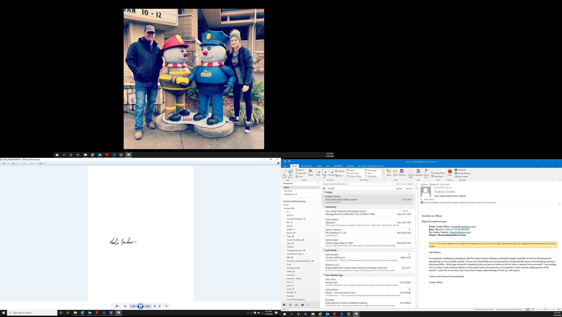

Leslie Jackson
Chief Deputy Fire Marshal

