Fire Marshal Division

April 27, 2023

J & D Sprinkler
315 W Main St.
Clayton, NC 28326

Re: Highland Elementary
1915 Buffalo Lake Rd.
Sanford, NC 27332

Application Number BCOM2112-0003

To Whom It May Concern,

Thank you for submitting the sprinkler system plans for Highland Elementary Sprinkler Addition. The plans have been carefully reviewed by a qualified code enforcement official to examine for compliance with the North Carolina Fire Prevention Code and all other fire protection regulatory documents. There are some items that were found during the plan review process that need to be addressed before a final inspection of the new facility can be given. These items are outlined and described below.

901.2.1 Statement of Compliance.

Before requesting final approval of the installation, where required by the fire code official, the installing contactor shall furnish a written statement to the fire code official that the subject fire protection system has been installed in accordance with the manufacture’s specifications and the appropriate installation standard. Any deviations from the design standards shall be noted and copies of the approvals for such deviations shall be attached to the written statement.

903.4 Sprinkler system monitoring and alarms.
  - All valves controlling the water supply for automatic sprinkler systems and water-flow switches on all sprinkler systems shall be electrically supervised according to the NC State Fire Code.

901.5 Installation acceptance testing.
  - All piping and attached appurtenances subjected to system working pressure shall be hydrostatically tested at 200 psi or 50 psi in excess of the system working pressure, whichever is greater, and shall maintain that pressure without loss for 2 hours. This test is required to be witnessed by a representative from the Harnett County Fire Marshal’s Office.
  - A contractor’s material and test certificate shall be furnished by the trained representative of J & D Sprinkler before approval.
  - A piping and hanger inspection is required before closure of ceiling system(s).
  - A sprinkler final inspection is required at completion of project.
  - Schedule all inspections with the Fire Marshal’s Office.
  - 910-893-0740

Thank you again for submitting the sprinkler plans for the Highland Elementary Sprinkler Addition. Please review the plans and adhere to any notes and alterations that were made in addition to the original drawings. These remarks are for the plans that were submitted and its original intent. These remarks do not apply if the original intent changes or what was submitted on the above date changes. If you have any questions, please do not hesitate to call this office.

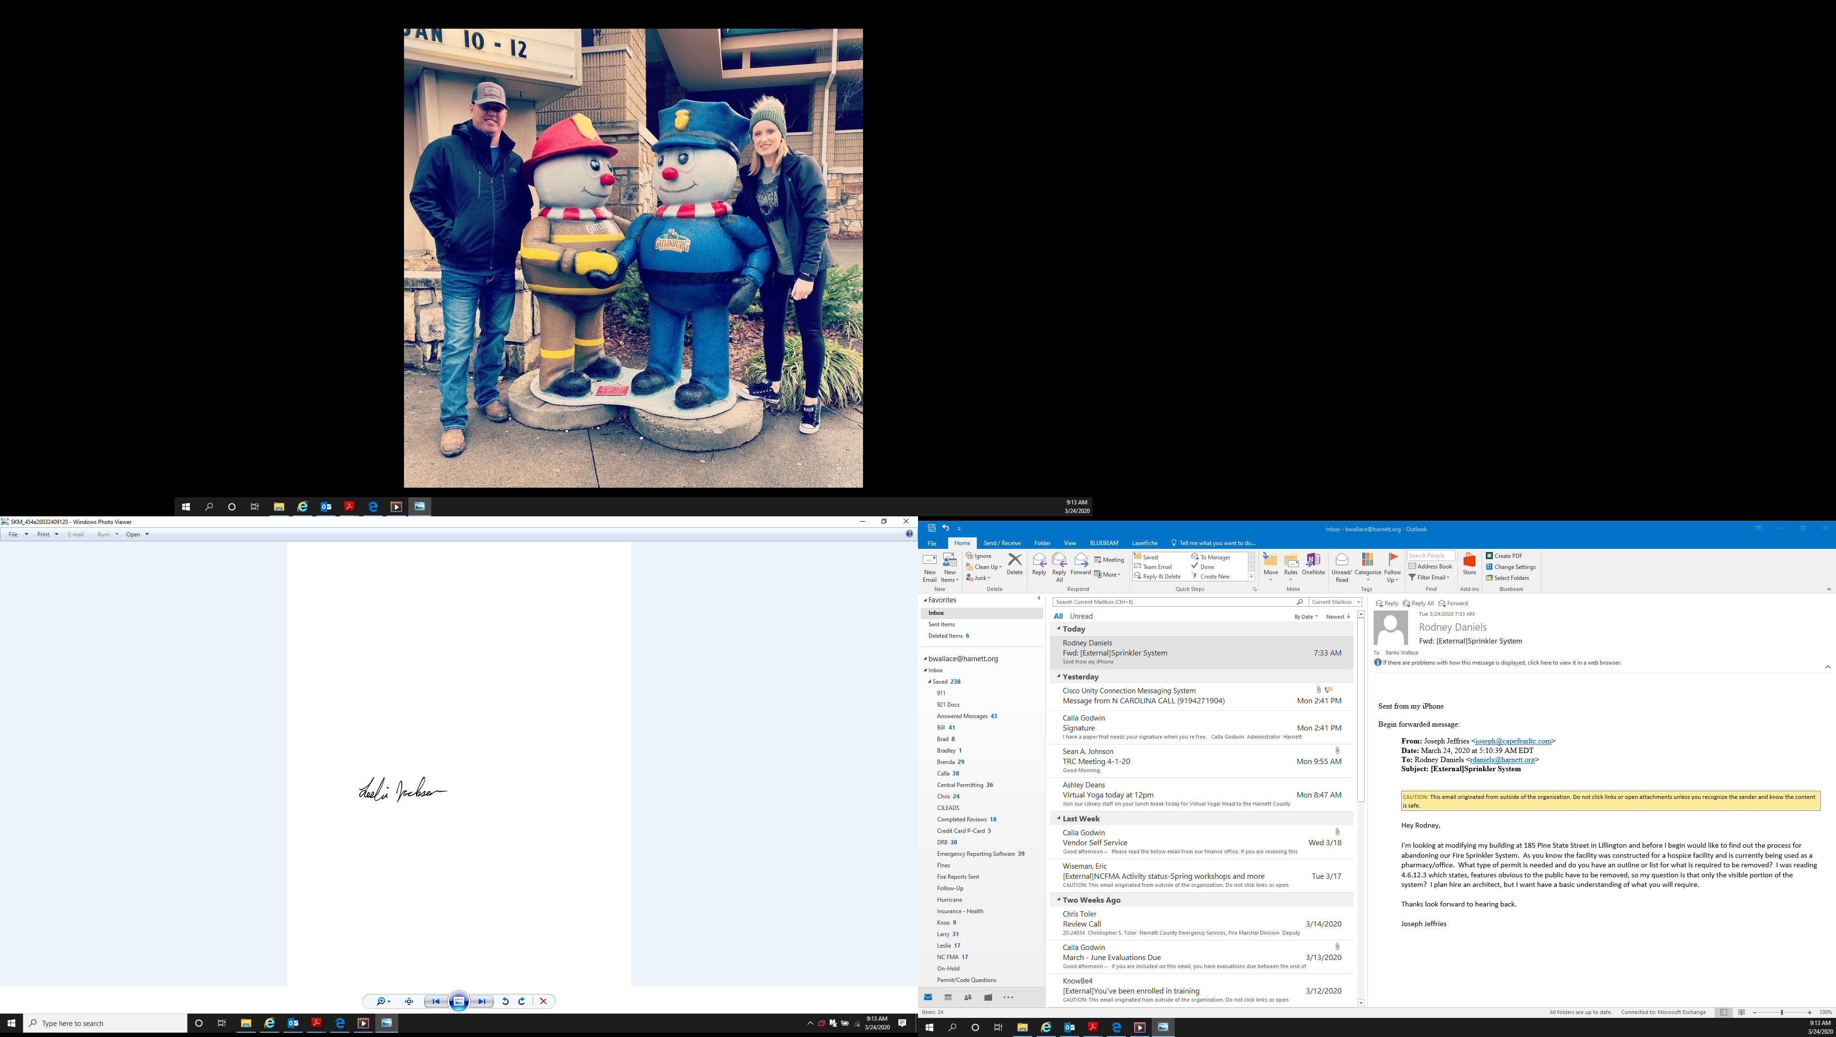
Sincerely,

Leslie Jackson
Chief Deputy Fire Marshal
lrjackson@harnett.com

