Fire Marshal Division

November 23, 2021

Re: Concrete Batch Plant Office
2520 US 401 S
Lillington, NC 27546

Application Number BCOM2110-0007

To Whom It May Concern,

Thank you for submitting the plans for the Concrete Batch Plant Office. The plans have been carefully reviewed by a qualified code enforcement official to examine for compliance with the North Carolina Fire Prevention Code and all other fire protection regulatory documents. There are some items that were found during the plan review process that need to be addressed before a final inspection of the new facility can be given. These items are outlined and described below.

- Fire Extinguishers
  - All Fire extinguisher shall be properly mounted and tagged by a fire extinguisher company.
- Address Numbers
- The physical address shall be installed on the building so that it is visible from the street.

- Means of Egress Illumination
- The means of egress illumination shall not be less than 1 foot-candle at the walking surface.

- Notes
- A final fire inspection is required.
- Schedule all fire inspections through the Fire Marshal’s Office.
(910) 893-0740

Thank you again for submitting the plans for the Concrete Batch Plant Office. Please review the plans and adhere to any notes and alterations that were made in addition to the original drawings. These remarks are for the plans that were submitted and its original intent. These remarks do not apply if the original intent changes or what was submitted on the above date changes. If you have any questions, please do not hesitate to call this office.

Sincerely,
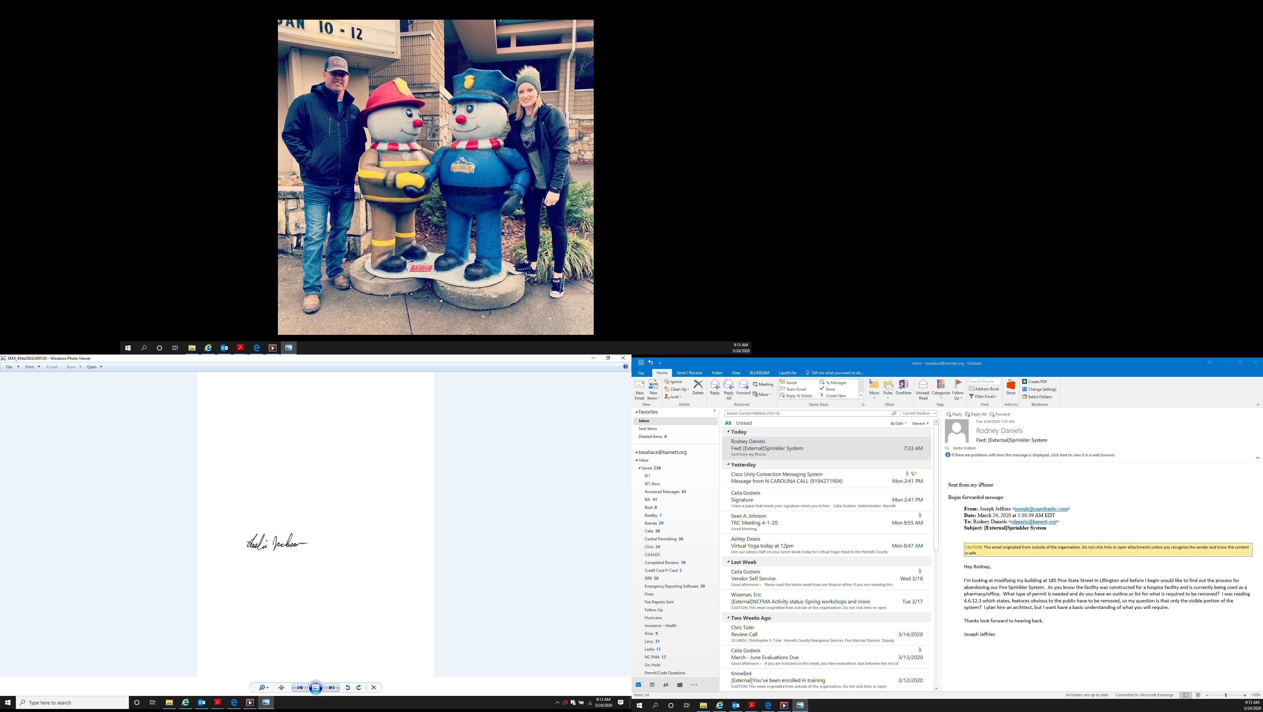

Leslie Jackson
Chief Deputy Fire Marshal

