Fire Marshal Division

June 28, 2021

George Rose
(910) 977-5822

Re: Seaview Crab Company
87 Carletta Drive
Cameron, NC 28326

Application Number BCOM2106-0004

To Whom It May Concern,

Thank you for submitting the plans for the new building. The plans have been carefully reviewed by a qualified code enforcement official to examine for full compliance with the North Carolina Fire Prevention Code and all other fire protection regulatory documents. There are some items that were found during the plan review process that need to be addressed before a final inspection of the new facility can be given. These items are outlined and described below.

- Physical Address
- The physical address of the building shall be posted in a conspicuous place so that it can be seen on approach from the road, access road, and/or parking lot.
- The numbers used to make up the physical address shall be at least 6 inches in height.

- Knox Box
  - A secure key box shall be installed on the new building that houses all keys to all the doors within the building in which the fire department would need access to in the event of an emergency.
    - Knox Box ID stickers shall be placed on all exterior doors in which entry to the building may be gained.
  - The box shall be mounted not to exceed 48 – 60 inches in height.
  - The basic model for the buildings should be at least a selection from the 3200 Series listed on the order form.
      - https://www.knoxbox.com/store/departmentSearch.cfm

- Fire Extinguishers
  - Fire Extinguishers shall be 2A:20BC and shall be placed with a travel distance to not exceed 75’
  - Fire extinguishers are to be mounted no higher than 5’ above the finished floor.

- Illumination Required
- The exit discharge shall be illuminated at all times the building spaces served by the means of egress is occupied
- Illumination level in all areas of the means of egress shall not be less than 1 foot-candle at the walking surface and shall have emergency power supply.

Thank you again for submitting the plans for the new building. Please review the plans and adhere to any notes and alterations that were made in addition to the original drawings. These remarks are for the plans that were submitted and its original intent. These remarks do not apply if the original intent changes or what was submitted on the above date changes. If you have any questions, please do not hesitate to call me directly at (910) 893-0740.

Again, thank you and we look forward to working with you during the construction period!

Sincerely,
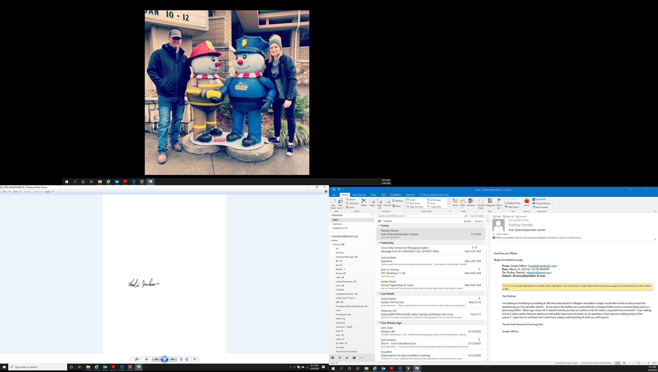

Leslie Jackson
Chief Deputy Fire Marshal

