Fire Marshal Division

August 9, 2021

Re: Natural Stone Design
148 Jarco Dr.
Fuquay-Varina, NC 27526

Application Number : BCOM2104-0004

To Whom It May Concern,

Thank you for submitting fire sprinkler plans for the Natural Stone Design Warehouse. The plans have been carefully reviewed by a qualified code enforcement official to examine for full compliance with the North Carolina Fire Prevention Code and all other fire protection regulatory documents. There are some items that were found during the plan review process that need to be addressed before a final inspection of the new facility can be given. These items are outlined and described below.

- Fire alarm construction permits.
  - A construction permit is required for the fire alarm installation. Submit complete shop drawings consistent with the architectural design documents, specifications and NFPA 72 for a separate review. Shop drawings shall include detail as described in Section 907.1.2 of the NC State Fire Code. Contractor must obtain the construction permit for the fire alarm system before commencement of any work.

- Fire Flow (NFF)
- Private fire service water mains shall be installed according to NFPA 24. All fire protection water mains shall be inspected by a fire official before covering. A contractor’s underground flush and test certificate is required at time of fire official inspection.

- Statement of Compliance
- Before requesting final approval of the installation, where required by the fire code official, the installing contactor shall furnish a written statement to the fire code official that the subject fire protection system has been installed in accordance with the manufacture’s specifications and the appropriate installation standard. Any deviations from the design standards shall be noted and copies of the approvals for such deviations shall be attached to the written statement.

- Fire Extinguishers
  - Fire extinguishers shall be installed in approved locations adjacent to exits, on each floor, within special hazard areas, and within 75ft. distance of travel.
  - The fire extinguishers provided shall have a minimum rating of 2A 10B:C and shall not be installed higher than 5 feet above the finished floor.
  - Fire extinguishers shall be serviced and tagged on a yearly basis by an authorized company.
  - Provide fire extinguishers in all special-hazard areas such as flammable and combustible liquids storage areas.

- Duct Smoke detectors.
- Smoke detectors installed in ducts shall be listed for the air velocity, temperature and humidity present in the duct. In facilities that are required to be monitored by a supervising station, duct smoke detectors shall report only as a supervisory signal and not as a fire alarm. They shall not be used as a substitute for required open area detection.

Acceptance tests.
  - A complete acceptance test is required to be witnessed by a representative from the fire marshal’s office in conjunction with the installing contractor for each of the following. Notify the fire marshal’s office in advance to schedule a test. (910) 893-0740.
    - Visual Inspection of Underground Line (with proper restraints)
    - Hydrostatic Test and Flush of Underground Line
    - Above Ceiling Inspection of ALL pipe and fittings
    - Hydrostatic Test of ALL piping
    - Flow Test of sprinkler/standpipe system
    - 100 % test of Fire Alarm System

Record of completion.
  - A record of completion in accordance with NFPA 72 verifying that the system has been installed in accordance with the approved plans and specifications shall be provided.
- Combustible Dust Operations.
  - Mechanical plans indicate dust collection system? Clarify if combustible dust operations are taking place in the building. Combustible dust operations must be installed in accordance with Chapter 22 of the NC State Fire Code as well as NFPA 654.
  - Provide more clarity and details on a separate plan sheet for proposed combustible dust operations.
  - Verify class and division wiring for dust collection equipment and environment?

- Knox Box
- A Knox Box is required to be installed on the building. Please see the link below to order Knox box. Paper order form available upon request.
- https://www.knoxbox.com/store/Knox-Box-3200-Series.cfm

- Markings.
- Where required by the fire code official approved signs or other approved
markings that include the words NO PARKING – FIRE LANE shall be provided for fire apparatus access roads to identify such roads or prohibit the obstruction thereof.

- Address Numbers
- The physical address shall be installed on the building so that it is visible from the approach side, minimum size of 6 inch.
- The numbers shall be of contrasting colors.

Please distribute these comments to any necessary and applicable persons involved in the design and construction of the building and systems specified within this letter. If you have specific questions or concerns we can be contacted at (910) 893-0740.

Thank you again for submitting fire sprinkler plans for Natural Stone Design Warehouse. Please review the plans and adhere to any notes and alterations that were made in addition to the original drawings. These remarks are for the plans that were submitted and its original intent. These remarks do not apply if the original intent changes or what was submitted on the above date changes. If you have any questions, please do not hesitate to call this office.

Please schedule all fire inspections through the Fire Marshal’s Office (910) 893-0740.

Again, thank you and we look forward to working with you during the construction period!

Sincerely,
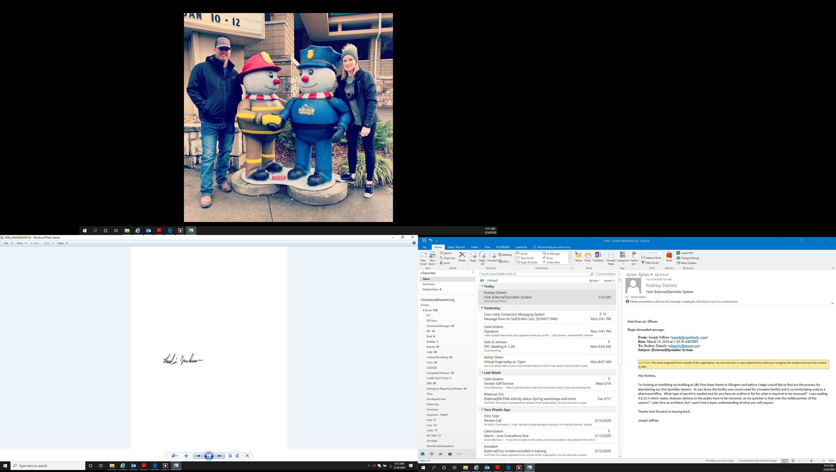

Leslie Jackson
Chief Deputy Fire Marshal

