Fire Marshal Division

February 05, 2021

RE: Kate Wilkins
Stouts and Ale’s Bottle Shop
30 S. McKinney Street
Coats, NC 27521

Application Number BCOM 2101-0012

To Whom It May Concern,

Thank you for submitting the plans for Stouts and Ale’s Bottle Shop. The plans have been carefully reviewed by a qualified code enforcement official to examine for full compliance with the North Carolina Fire Prevention Code and all other fire protection regulatory documents. There are some items that were found during the plan review process that need to be addressed before a final inspection of the new facility can be given. These items are outlined and described below.

- Exits
  - The side exit door needs to swing in the direction of travel.

- Fire Extinguishers
  - Fire extinguishers shall be placed in locations as approved by the fire code official.
  - The fire extinguishers provided shall have a minimum rating of 2A 10B: C and shall not be installed higher than 5 feet above the finished floor.

- Emergency Lighting
  - All emergency lighting, provided prior to up fit, shall be in proper operating condition at time of final inspection.
  - Any changes made in illumination requirements, due to equipment placement or storage arrangements shall be addressed before final inspection.
  - The means of egress, including the exit discharge, shall be illuminated at all time the building space is served by the means of egress is occupied.
    - Means of egress consist of three separate and distinct parts: the exit access, the exit and the exit discharge.
  - The means of egress illumination shall not be less than 1 foot-candle at the walking surface.

- Knox Box
Keys for front entrance door and access doors to fire service equipment rooms shall be provided to be placed in the complex Knox box installed on the premises.

Notes:

Please call to schedule fire final through the Fire Marshal’s Office at (910) 893-0742.

Thank you again for submitting the plans for Stouts and Ale’s Bottle Shop. Please review the plans and adhere to any notes and alterations that were made in addition to the original drawings. These remarks are for the plans that were submitted and its original intent. These remarks do not apply if the original intent changes or what was submitted on the above date changes. If you have any questions, please do not hesitate to call this office

Again, thank you and we look forward to working with you during the construction period!

Sincerely,

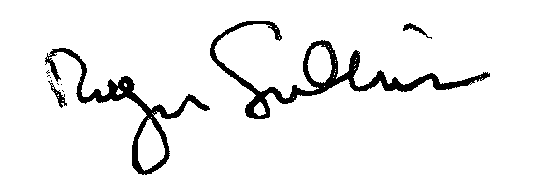
Roger Sullivan
Deputy Fire Marshal

