September 11, 2018

Mr. Stuart Matthews  
P.O. Box 1360  
Angier, NC 27501

**RE: Notice of Zoning Assignment Approval, Case: RZ-18-02**

Dear Mr. Matthews,

Please be advised that your application to assign zoning to the property located at NC 210 NORTH

just south of Harnett Central Road being PIN #0662-12-8254.000.from Harnett County RA30

Residential Agricultural to Lillington GB General Business, was approved by the Lillington Board of

Commissioners at their regular business meeting on May 15, 2018.

The Lillington Planning Board recommended approval of the request at their May 4, 2018 meeting. A public hearing was subsequently held in accordance with § 160A-384 to consider the request on May 15, 2018. Afterwards, the Town Board approved the zoning assignment for the parcel referenced above.

This approval is granted in accordance with CHAPTER 7, SECTION 7.10 TEXT AMENDMENTS AND MAP AMENDMENTS, of the Town of Lillington Unified Development Ordinance.

If you have any questions, please contact me at (910) 893-0311 or mparrish@lillingtonnc.org.

Sincerely,

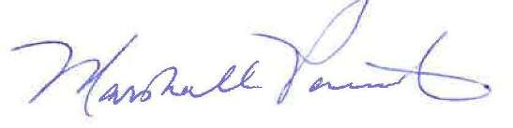

Marshall L. Parrish

Town Planner and Public Information Officer

CC: Tony Buzzard, Town Attorney