Fire Marshal Division

July 27, 2018

WD Partners / Matt Davis

Re: Walmart Sore # 6958
2660 NC Highway 24-87
Cameron, NC. 28326

Application Number BCOM1807-0015

Mr. Yonkers,
Thank you for submitting the plans for the Walmart Pick-Up Renovation. The plans have been carefully reviewed by a qualified code enforcement official to examine for compliance with the North Carolina Fire Prevention Code and all other fire protection regulatory documents. There are some items that were found during the plan review process that need to be addressed before a final inspection of the new facility can be given. These items are outlined and described below.

- 1006.1 Means of Egress Illumination
- The means of egress, including the exit discharge, shall be illuminated at all time the building space is served by the means of egress is occupied.
- Means of egress consist of three separate and distinct parts: the exit access, the exit and the exit discharge.
- The means of egress illumination shall not be less than 1 foot-candle at the walking surface.

- 901.2.1 State of Compliance.
  - Before requesting final approval of the installation, where required by the fire code official, the installing contactor shall furnish a written statement to the fire code official that the subject fire protection system has been installed in accordance with the manufacture’s specifications and the appropriate installation standard. Any deviations from the design standards shall be noted and copies of the approvals for such deviations shall be attached to the written statement.
  - All work shall be performed in accordance with NFPA 13 and the NCSFC.

- Notes
- Please call 910-984-4003 to schedule all Fire Marshal inspections.

Thank you again for submitting the plans for the new Walmart Store. Please review the plan review notes and if you have any questions, please do not hesitate to call this office.

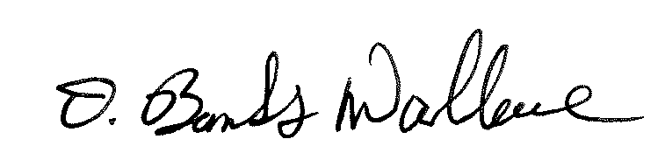
Sincerely,

D. Banks Wallace
Chief Deputy Fire Marshal

